**Software Engineering Department**

**פרויקט גמר – תשע"ט**

**Smart Shooting Rang**

**Dor Ben Yehuda**



**מנחה אקדמי: מר שי תבור אישור: תאריך:**

**רכז הפרויקטים: דר' אסף שפיינר אישור: תאריך:**

Report #1 - SSR Project Proposal

**Table of Contents**

1. Introduction…………………………………………………………………………………………………..

1.1. System Project Manager…………………………………………………………………...

1.2. Problem & Proposal Solution …………………………………………………………..

1.3. Definitions, Acronyms, and Abbreviations………………………………………….

2. Market Survey………………………………………………………………………………………………..

2.1. Main Goal…………………………………………………………………………………………

2.2. Idea Characterization and Formulation……………………………………………..

2.3. Target Audience………………………………………………………………………………..

2.4. Findings……………………………………………………………………………………………

2.4.1. Primary Checks…………………………………………………………………..

2.4.2. Deeply Checks…………………………………………………………………….

2.5. Efficiency and Impact……………………………………………………………………....

3. Specific Requirements & Architecture.…………………………………………………………….

3.1. Functional Requirements………………………………………………………………….

3.2. Software Requirements…..………………………………………………………………..

4. Appendices…………………………………………………………………………………………………….

4.1. Work plan…………………………………………………………………………………………

4.2. Risk Management……………………………………………………………………………..

4.3. UML Diagrams………………………………………………………………………………….

4.4. Database Collections…………………………………………………………………………

4.5. Use-Cases………………………………………………………………………………………....

4.6. User Requirements Document…………………………………………………………….

**1. Introduction**

This stage gives a scope description and overview of the projects first steps. Planning management aspects and analyse requirements of the product being developed. Offers a preliminary solution and investigates the software engineering characteristics of the project.

**1.1 System Project Manager**

|  |  |  |
| --- | --- | --- |
| Link | System | # |
| [Link1](https://github.com/dor132133/SSR-Smart-Shooting-Range) | Repository | 1 |
| [Link2](https://github.com/dor132133/SSR-Smart-Shooting-Range/wiki) | Diary | 2 |
| [Link3](https://github.com/dor132133/SSR-Smart-Shooting-Range/projects/1) | Project Manager | 3 |
| Tablet with Installed application | Distribution | 4 |

**1.2 Problem & Proposal Solution**

Today, shooting range clubs find it **difficult** to manage and document their activities on an ongoing basis. The ability to systematically follow different and varied firing sessions by many warriors, **hardly exists**. The training process of a warrior requires the ability to monitor his physical and professional achievements in order to make the training process more efficient and professional.

In addition, there is a desire and need to improve the shooting range itself, in order to give the warrior a realistic experience as much as possible. Therefore, a smart shooting range will answer this need by a command and control system of active and passive hardware components.

**The Solution**

A smart shooting range with robotic targets and motion sensors, which are autonomously controlled according to various predetermined plans. In addition, a command and control application will be added, with the ability of processing and managing data, calculation of speeds and times, statistical calculations and issuing reports.

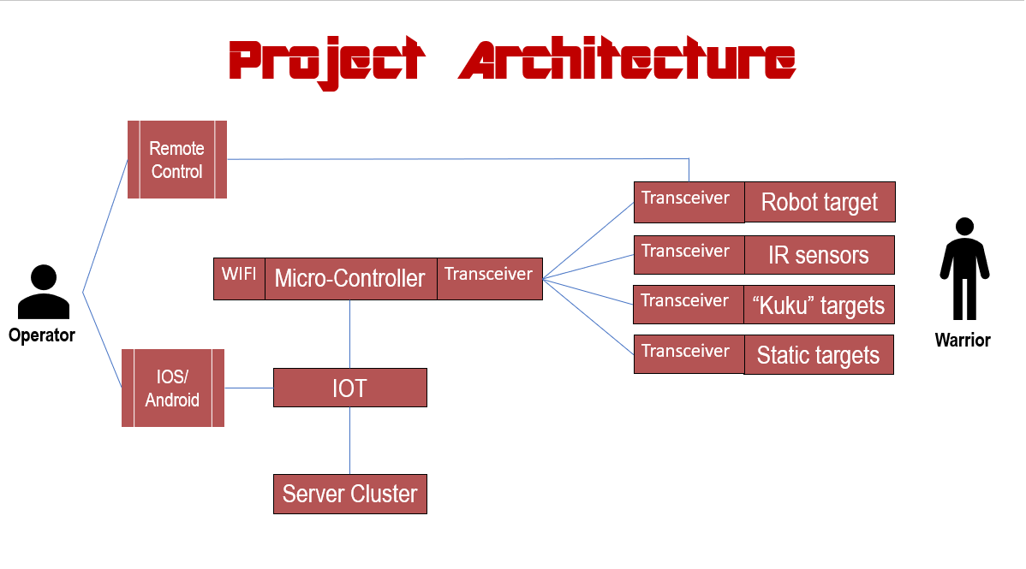

**1.3. Definitions, acronyms, and abbreviations**

|  |  |
| --- | --- |
| **Term** | **Definition** |
| SSR | Smart Shooting Rang |
| SR | Shooting Range |
| MC | Micro-Controller |
| Transceiver | A device comprising both a transmitter and a receiver that are combined and share common circuitry or a single housing. |
| Warrior | Someone who using the SR as a shooter, can be a costumer or guide. |
| Operator | Someone who run the SR scenario, using the management app. |
| Administrator | System administrator who is given specific permission for managing and controlling the system. |
| Web-Server | A server which provide RESTful API. |
| RESTful API | an application program interface (API) that uses HTTP requests to GET, PUT, POST and DELETE data. |
| Node-JS | Node.js is an open-source, cross-platform JavaScript run-time environment that executes JavaScript code outside of a browser. |
| Node-JS server | handling multiple events asynchronously. |
| ESP | The chosen micro-controller having WIFI module. |
| Front-end | The mobile application. The part of the system that the operator can see and interact with. |
| Back-end | The server services – web-server, database, and other processing services. |
| SR components | All shooting range objects in the field: walls, robotics targets, motion sensors and recoil sensor |
| SR scenario | Session of all shooting events of a warrior during a runway, while recording all events. |
| Robotics targets | Motorized shooting targets with recoil sensor, micro-controller and transceiver module. |

**2. Market Survey**

**2.1. Main Goal**

How unique is the project? How innovating is the project? How exciting is the project? There are a few reasonable major purposes for doing market survey:

* Gain critical customer feedback, understand customer inclination towards purchasing products.
* Understand customer inclination towards purchasing products.
* Enhance existing products and services.
* Make well-informed business decisions.

**2.2. Idea Characterization and Formulation**

SSR product is a complete product, combining several technological systems: Hardware and real time system, Command and control system and Data processing and management system. The product is a modular product that can be integrated into any existing shooting range without any preconditions.

The idea of the project is to integrate hardware and software components that are capable of managing, monitoring, controlling, and supervising the preparing of warrior shooting skills process.

**2.3. Target Audience**

According to the official data of the Ministry of Public Security in Israel today, there are 292,625 civilian weapons. About 157 thousand of which are private weapons. About 130,000 weapons are defined as 'organizational'.

In addition, there are currently more than 50 public and private security ranges, which serve different audiences, including military and general security personnel, security guards, private individuals and amateurs. Each of the above mentioned individuals are required by law to undergo the process of training firearms and even to refresh this skill every few months.

**2.4. Findings**

**2.4.1. Primary Checks**

In an initial search for similar products on the market, searches were conducted for several keywords related to the domain:

"Shooting range", "Smart firing range", "Training shooting skills", "Robotic shooting targets", "Measures to assess a fighter's shooting skills".

Each such search presented the first results of similar products, similar systems and training programs that are currently available on the market.

**2.4.2. Deeply Checks**

**A.** As part of an examination of relevancy, I went to see a shooting range, watched his conduct and spoke with shooting guides.

According to the findings, today a shooting range scenario includes a track structure that changes between the firing sessions and adapted to the training type. The targets of the shooting are human figures standing in different places in the arena. During the shooting scenario, the coach follows the warrior's steps and measures time manually[. http://caliber.webdna.co.il/Professional-Courses](.%20http:/caliber.webdna.co.il/Professional-Courses)

|  |  |
| --- | --- |
| Advantages | Disadvantages |
| Follow-up by the guide | Poor documentation capability |
| A quick change of the shooting range | Time measurement is not accurate |
| Regardless of technology | Involvement of many people |
|  | Reports are following up by written forms |

**B.** Robotics targets, I watched a video showing shooting practice at a shooting range with a robotic target driving randomly across the range. The warrior must deal with moving targets. <https://www.youtube.com/watch?v=QSgNPiAvuHU>.

|  |  |
| --- | --- |
| Advantages | Disadvantages |
| Illustration of moving objects | High financial investment |
| Improved response times | Feedback of shooting hits as the warrior sees fit. |
|  | Manual time measurements |

**C.**  A laser shooting range, the warrior grips a weapon-like shape and directs it towards the targets that absorb the laser beam. If the laser beam hits the target announce. Laser ranges can be found in urban areas.

|  |  |
| --- | --- |
| Advantages | Disadvantages |
| Clean, quiet and does not require the maintenance of weapons and ammunition | High financial investment |
| Has a quick feedback system | Does not simulate a real shooting scenario, without recoil and without a sense of possession of weapons |
| Laser ranges can be set up in city areas | Does not examine the warrior under stress or distress. |

**D.** kit of a range of shooting targets capable of identifying shots hit and transmitting data to a nearby docking station.

The docking station allows the warrior to watch and processing the shooting data in a dedicated application. <http://advancedtargettech.com/>

|  |  |
| --- | --- |
| Advantages | Disadvantages |
| Multiple-threat and judgmental exercises. | Come as a kit, not a modular system. |
| Driven from mobile phone. | Inability to compare many shoot sessions  among many warriors. |
| Automate scoring. | The movement of the warrior cannot be identified. |
|  | Impossible to adapt shooting tracks to a warrior. |

**2.5. Efficiency and Impact**

A smart shooting range with robotic targets and motion sensors, which are autonomously controlled according to various predetermined plans. In addition, a command and control application will be added, with the ability of processing and managing data, calculation of speeds and times, statistical calculations and issuing reports. SSR system, which includes 3 different systems, capable of "talking" among them, will serve as the infrastructure for the entire process of training the warrior in the most efficient and best manner. The system provides a solution to the main problems that exist today in the field, and makes the shooting range "smart", accessible and dynamic. SSR tackles most of all disadvantages mentioned above.

SSR will respond to a wide target audience that required repetitive training services and has the ability to grow and reach similar audiences around the world.

**3. Specific Requirements**

This section contains all the functional and quality requirements of the system. It gives a detailed description of the system and all its features.

**3.1 Functional Requirements**

In many countries there is a need to train security personnel for many various purposes. Israel known as a country that engages heavily in defense and the training of combatants.

In Israel, there are quite a few shooting clubs, both private and public, which prepare the fighters to be ready when the time comes. The need to **streamline** the training process is requested, both in terms of time, both in terms of quality and in terms of money.

In order to meet these requirements, the proposed idea is to **convert** existing shooting ranges to "smarter" by installing a number of technological systems with good integration capability.

First, a **mobile management and control application** is required.

* SR operator and administrator will be the major application costumers.
* The application will include:
  + A graphic mapping of the shooting range and arrangement of the SR components on the map.
  + Create and view of reports and lists.
  + Management of warriors personal and professional information.
  + Displays statistical information of warriors and teams.
  + Launching of SR scenarios system and displays all information recorded during the session.

Figure 1

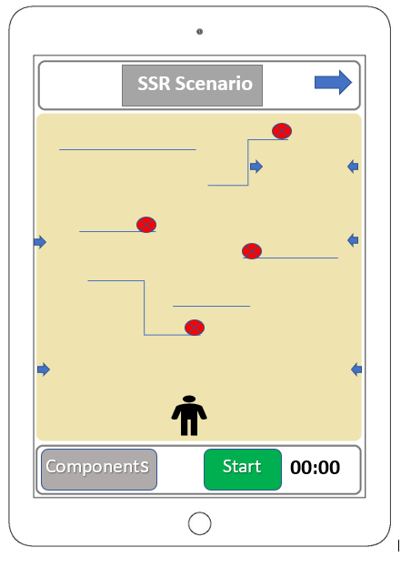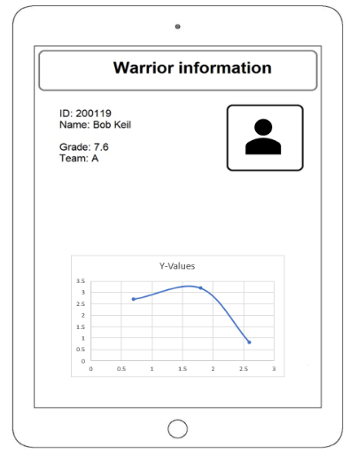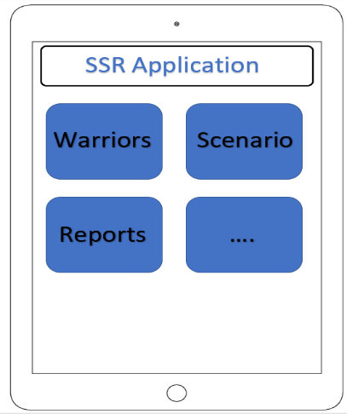

Figure 2

Figure 3

A **command and control hardware system**, each SR component installed by MC and transceiver in purpose to communicate with the main shooting range controller – the ESP.

The ESP manage the SR scenario "in the field" listening and responding to any SR scenario events – target shooting hits, sensors crossing and targets movement. In addition, The ESP documents all SR scenario events according to their occurrence.

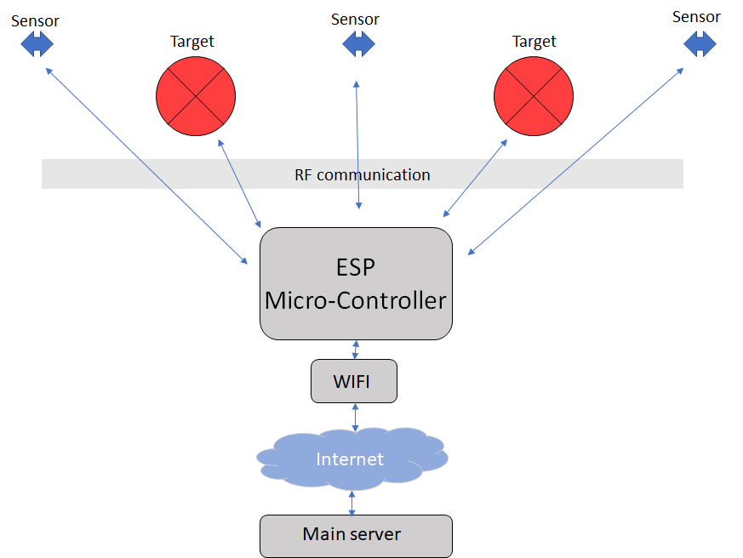

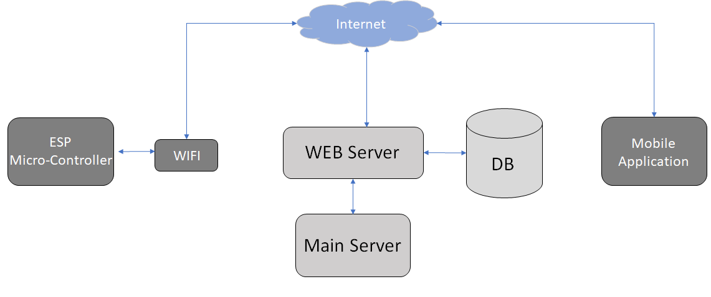A **main server cluster** provides all processing, communications and data management services. Functions as an integrator between the frontend app and the ESP part. The communication with the in server performed by a web-server service through the global internet network.

**SR scenario**, at the beginning of each shooting session, the operator determines the map structure and push the start button. Since than all the scenario runs autonomously, act and response according to the warrior moves. At the end all sessions records are send back to the main server for processing and storing.

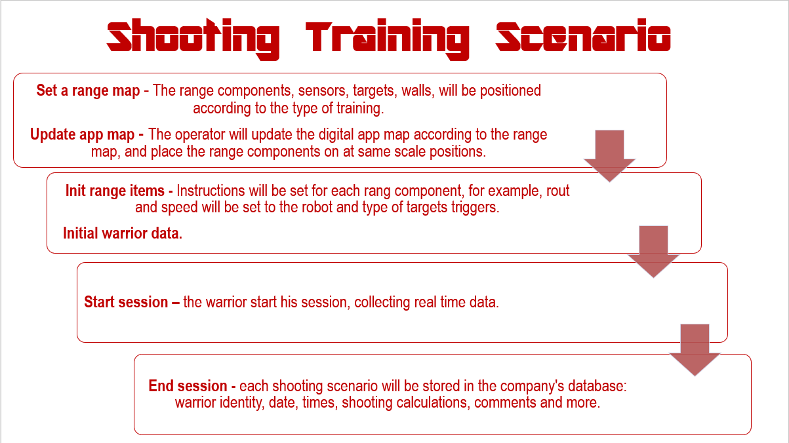

**3.2. Software Requirements**

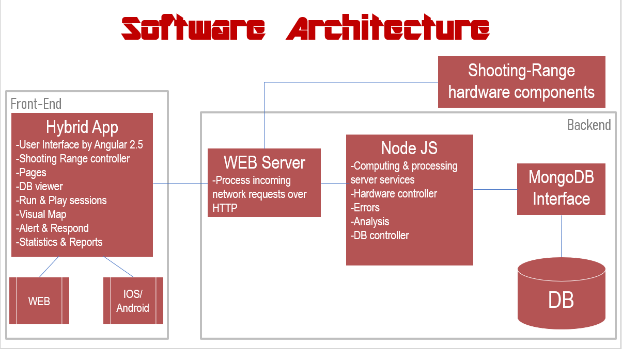Software development has some serious challenges. Changes in software development are unavoidable, changes occur rapidly and accommodating these changes to develop complete software. SSR project has a few software challenges that requires a good architecture design and well making decisions. There are 3 software parts in this project, frontend app that runs on mobile tablet, main server cluster that divided into several services and real time micro-controller side. All parts should integrate perfectly, mainly because each part run on a different machine, programmed on different work frames in a different languages. Another important challenge is the communication issue that should be accessible and scheduled between all parts. each part belongs to different network, for instance, the main server runs on some cloud/remote machines, while the ESP connecting to the local SR network using WIFI module.

The chosen work frames and the programme languages are:

* Angular2.5 writing in TypeScript for the mobile hybrid application.
* Node-JS writing in JavaScript for the main server services.
* C/C++ for the ESP real time chip.
* MongoDB as a database service.
* RESTful API as the main server gatekeeper and communicator.
* TCP/IP as a communication protocol.
* ** ESP using RF transceivers to communicates against all SR components

**5. Appendices**

**5.1. Work Plan**

|  |  |  |  |
| --- | --- | --- | --- |
|  | Mission | Description | Date |
| 1 | Meeting with the client. | Introduce meeting with the client, talking about the problem. | 10.13.18 |
| 2 | Second Meeting with the client. | Solutions suggestions | 10.22.18 |
| 3 | Micro controllers, motors and sensors. | Selection of mechanical and electrical components. | 11.01.18 |
| 4 | Hardware Control. | Mechanical control of all shooting range hardware components: moving targets and sensors | 11.11.18 |
| 5 | First design of project environment. | includes hardware and software components, according to the needs of the system, environmental constraints and economic constraints. | 11.30.18 |
| 6 | Project architecture design | Primary project architecture design – according to client requirements | 12.06.18 |
| 7 | Software architecture design | Primary software architecture design – according to client requirements | 12.12.18 |
| 8 | Report #1 | Start working on project proposal | 12.13.18 |
| 9 | Setting up a web server | The main services integrator, RESTful - API | 12.20.18 |
| 10 | Database | Establishing a database service. | 12.25.18 |
| 11 | Web-server and DB integration | Create collection and insert documents to db using web server | 12.30.18 |
| 12 | First ESP and Main server communication | Configured the ESP to be able communicate external internet network | 01.07.19 |
| 13 | First mobile application components | Start writing mobile application | 01.16.19 |
| 14 | Pages Creations | Mobile app. | 01.20.19 |
|  |  |  |  |

**5.2. Risk Management**

|  |  |  |  |
| --- | --- | --- | --- |
| Risk | Severity | Response |  |
| 1 | Wrong working plan design. | High | Clearly define goals, sub-goals and milestones placing. |
| 2 | Project scope extends beyond project limits. | High | Reach complete understanding between client, project programmer and project Supervisor regarding expectations, abilities and project requirements. |
| 3 | Working with new tools in an unfamiliar environment | Medium | Getting familiar with the software tools used for development by attending classes, hands down experience, and various tutorials. |
| 4 | Change requirements | Medium | The client changes its requirements in such a way that shifts the timetable of the project or defines the project as not meeting client's requirements. |
| 5 | Incorrect system size assessment | High | Provide the main requirements by adjusting them to constraints. |
| 6 | Communicating with the customer | Medium | The customer is busy and it can cause delay on development, if the product is as expected or not. the answers can be delayed, and it will influence the whole project. |
| 7 | Dependence on multiple hardware components | High | Interfacing between different hardware components and using many communication protocols increases the likelihood of communication falls. |
| 8 | Too many errors during testing | Medium | Finding too many bugs during testing can delay the termination of the current iteration in such a way that can delay the termination of the project in time. |
| 9 | Use new technology | High | As a result of the client requirements it been ask to create a realistic shooting range, which functions and responds to combat operations in the field while integrating a control system |
| 10 | Real Time response | Medium | Control of mechanical and electronic components should response in a short time. |

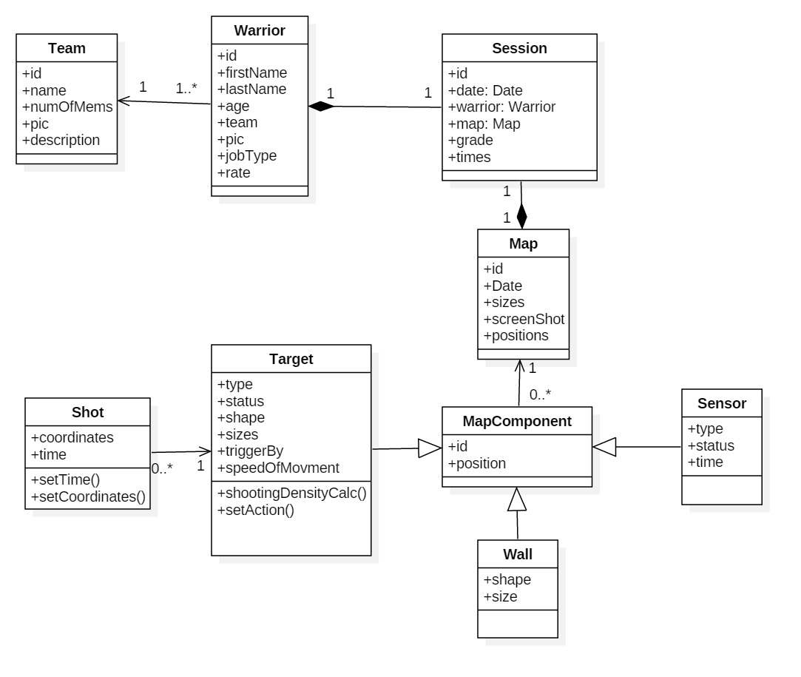**5.3. UML Diagrams**

**5.4. Database Collections**

**5.5. Use-Cases**

